VISVESVARAYA TECHNOLOGICAL UNIVERSITY
Jnana Sangama, Belagavi – 590018


Menstrumate: AI-Powered Menstrual Wellness and Support Platform

Submitted in partial fulfillment of the requirements as a part of the curriculum,

Bachelors of Engineering in Artificial Intelligence and Machine Learning

Submitted by

M Pallavi 1CR24AI067

Kanchan Bhattarai 1CR24AI058

Krupa Pramod Pattanshetti 1CR24AI065

Under the Guidance of
Divyamani LS
Assistant Professor
Department of Artificial Intelligence and Machine Learning


Department of Artificial Intelligence and Machine Learning
CMR INSTITUTE OF TECHNOLOGY
132, AECS Layout, Kundalahalli, ITPL Main Rd, Bengaluru – 560037


CERTIFICATE
Certified that the Mini Project entitled “Menstrumate: AI-Powered Menstrual Wellness and Support Platform” is presented by
M Pallavi 1CR24AI067,
Kanchan Bhattarai 1CR24AI058,
Krupa Pramod Pattanshetti 1CR24AI065,

bonafide student(s) of CMR Institute of Technology in partial fulfillment of the requirements as a part of the curriculum, Bachelors of Engineering in Artificial Intelligence and Machine Learning, of Visvesvaraya Technological University, Belagavi during the year 2025-26. It is certified that all correction/suggestion indicated for Internal Assessment have been incorporated in the report deposited in the departmental library. The Entrepreneurial Project report has been approved as it satisfies the academic requirements in respect of the Technical Seminar prescribed for the bachelor of engineering degree.

(Divyamani LS) (Dr. Shyam P Joy)

Signature of the Guide Signature of the HOD

DECLARATION
We, the undersigned, students of CMR Institute of Technology, hereby declare that this mini project report titled
“Menstrumate: AI-Powered Menstrual Wellness and Support Platform”
is a record of our original work done under the supervision of Divyamani LS, Assistant Professor, Department of Artificial Intelligence & Machine Learning. And has not formed the basis of award of any other degree, in this or any other Institution or University. In keeping with the ethical practice in reporting scientific information, due acknowledgements have been made wherever the findings of others have been cited.

1. [M Pallavi] (1CR24AI067: ______________________) (Signature )
2. [Kanchan Bhattarai] (1CR24AI058: ______________________) (Signature )
3. [Krupa Pramod Pattanshetti] (1CR24AI065: ______________________) (Signature )

ABSTRACT
Menstrumate is an AI-powered menstrual wellness and support platform designed to assist users in managing menstrual health through an integrated digital ecosystem. The platform combines cycle tracking, symptom monitoring, wellness reminders, educational resources, entertainment features, and community interaction into a single web-based application.

The system provides intelligent notifications for cycle reminders, hydration, wellness activities, and emotional support. It also includes a community section that enables users to communicate through messaging, voice notes, and video interactions to encourage emotional well-being and support. Educational modules provide health-related information using YouTube resources and reference materials, while entertainment features such as games and stress-relief content improve user engagement.

The application was developed using HTML, CSS, JavaScript, Node.js, Express.js, and MongoDB. The project aims to create a safe, supportive, and informative environment for menstrual wellness management while improving accessibility, awareness, and user experience.

ACKNOWLEDGEMENTS
It is my proud privilege and duty to acknowledge the kind of help and guidance received from several people in preparation of this report. Apart from my own, the success of this report depends largely on the encouragement and guidelines of many others. It would have not been possible to prepare this report in this form without their valuable help, co-operation and guidance.
I would like to express my deep sense of gratitude to our Principal Dr. Sanjay Jain, CMR Institute of Technology, Bangalore for his motivation and for creating an inspiring atmosphere in college by providing state of the art facilities for preparation and delivery of this report.
My sincere thanks to Dr. Shyam P Joy , Head of Department of Artificial Intelligence and Machine Learning, for his whole-hearted support in completion of the Entrepreneurial Project.
I am highly indebted to my project guide Divyamani LS, Assistant Professor for guiding and giving timely advice and suggestions in the successful completion of this project.
My sincere thanks to Sandhya Kumari, Assistant Professor, mini-project coordinator for having supported the work related to this project.
Last but not the least, I would like to put forward my heartfelt acknowledgement to all my classmates, friends and all those who have directly or indirectly provided their overwhelming support during my seminar work and the development of this report.

TABLE OF CONTENTS
[instruction: click and update the entire table before final submission]
CERTIFICATE 2
DECLARATION 3
ABSTRACT 4
ACKNOWLEDGEMENTS 5
1. INTRODUCTION 8
1.1 Overview 8
1.2 Problem Statement 8
1.3 Objectives 8
1.4 Scope of the Project 9
2. LITERATURE SURVEY 10
3. METHODOLOGY 11
3.1 SYSTEM DESIGN 11
3.1.1 System Requirements 11
3.1.2 System Architecture / High-Level Design (HLD) 12
3.1.3 Database Design (ER Diagram / Schema) 14
3.1.4 Module Description 14
3.1.5 Dataset Description 16
3.1.6 Model(s) Used 16
3.2 IMPLEMENTATION 17
3.2.1 Technology Stack 17
3.2.2 Implementation of Key Modules 18
3.2.3 Data Preprocessing 24
3.2.4 Feature Engineering 24
3.2.5 Model Training 24
3.2.6 Model Evaluation 24
3.2.7 Comparison of Models 24
3.2.8 Model Deployment 24
4. RESULTS & DISCUSSIONS 25
4.1 Testing Methodology 25
4.2 Screenshots of Results 25
4.3 Performance Evaluation 28
4.4 Discussion 28
5. CONCLUSION 29
5.1 Conclusion 29
5.2 Limitations 29
5.3 Future Scope 29
6. REFERENCES 31
APPENDIX A: SOURCE CODE 32
APPENDIX B: ADDITIONAL SCREENSHOTS 33

1. INTRODUCTION

1.1 Overview

Menstrual health and wellness have become increasingly important topics in modern healthcare and digital wellness systems. Many individuals face challenges related to cycle tracking, emotional stress, lack of awareness, and limited access to supportive healthcare resources. Existing applications often focus only on period tracking while ignoring emotional wellness, community interaction, and educational support.

Menstrumate is designed as an integrated menstrual wellness platform that combines healthcare assistance, AI-based reminders, emotional support, educational resources, entertainment, and community engagement. The platform provides users with cycle tracking, symptom monitoring, wellness notifications, educational content, stress-relief activities, and social interaction features.

The application aims to create a safe and supportive digital environment where users can manage their menstrual wellness while also receiving emotional encouragement, educational guidance, and lifestyle support through a modern web-based system.

1.2 Problem Statement

Many existing menstrual health applications focus only on basic cycle tracking and fail to provide emotional wellness support, educational guidance, stress-relief activities, and community interaction in a single platform. Users often depend on multiple disconnected applications for healthcare information, emotional support, wellness reminders, and social communication, which reduces accessibility and user convenience.

This problem mainly affects teenagers and women who require a safe, informative, and supportive environment for managing menstrual wellness. Without an integrated system, users may experience lack of awareness, poor wellness management, emotional stress, and limited access to supportive healthcare resources.

1.3 Objectives

• To develop a web-based menstrual wellness and support platform.

• To implement menstrual cycle tracking and smart reminder notifications.

• To design a community interaction system supporting messaging, voice notes, and video communication.

• To implement educational modules using healthcare videos and informational resources.

• To integrate entertainment and stress-relief features such as games and wellness activities.

•To develop a cart and checkout system for wellness-related products and services.

1.4 Scope of the Project
This project focuses on developing a web-based menstrual wellness platform that integrates cycle tracking, wellness reminders, educational resources, entertainment activities, community interaction, and product management into a single system. The application aims to improve healthcare awareness, emotional wellness, and user engagement through a supportive digital environment.

The project is limited to a web-based implementation and currently includes simulated payment functionality, locally managed notifications, and basic AI-assisted wellness support. The system does not cover real-time medical diagnosis, advanced AI healthcare analysis, or large-scale production deployment.

2. LITERATURE SURVEY
1. Flo Health Application:
Flo is a popular menstrual cycle tracking application that helps users monitor periods, ovulation cycles, symptoms, and overall reproductive health. The application provides reminders and health insights based on user data. However, it mainly focuses on tracking functionality and offers limited emotional wellness support, entertainment features, and community interaction, which are addressed in the proposed system.

2. Clue Application:
Clue is a menstrual health and cycle prediction platform designed to provide scientific and data-driven health tracking. It allows users to record symptoms, moods, and health patterns. Although Clue provides accurate cycle tracking and educational insights, it lacks integrated entertainment modules, wellness engagement activities, and interactive community communication features included in the proposed project.

3. AI-Based Healthcare Assistance Systems:
Modern AI-assisted healthcare platforms provide personalized recommendations, wellness reminders, and symptom analysis using intelligent algorithms. These systems improve accessibility and automation in digital healthcare. However, many existing systems focus primarily on medical assistance and do not integrate emotional wellness, stress-relief activities, and community-based support into a unified platform.

4. Online Wellness and Community Platforms:
Online support communities allow users to interact, share experiences, and provide emotional support through messaging and communication features. These platforms improve user engagement and emotional well-being. However, most existing systems are disconnected from healthcare tracking and educational resources, whereas the proposed system integrates wellness tracking, education, entertainment, and community interaction within a single ecosystem.

3. METHODOLOGY

3.1 SYSTEM DESIGN

The Menstrumate application follows a client-server architecture that integrates frontend interfaces, backend APIs, and database management into a unified menstrual wellness platform. The system is designed to provide healthcare assistance, emotional support, educational resources, entertainment features, and community interaction through a modular and scalable structure.

The frontend layer is developed using HTML, CSS, and JavaScript to provide an interactive and responsive user experience. Users can access features such as cycle tracking, wellness reminders, community communication, entertainment activities, educational resources, and product management through the user interface.

The backend layer is implemented using Node.js and Express.js. This layer handles authentication, API requests, notification logic, community interaction, cycle calculations, cart functionality, and application processing. APIs are used to establish communication between the frontend and backend components.

MongoDB is used as the database layer for storing user profiles, cycle tracking data, community messages, notifications, and cart information. Additional modules such as entertainment systems, educational resources, voice/video communication, and notification services are integrated within the application layer to improve user engagement and emotional wellness support.

The modular structure of the system improves maintainability, scalability, and future enhancement capabilities while ensuring efficient interaction between different components of the application.

3.1.1 System Requirements
Functional Requirements

1. The system shall allow users to register and log in securely.
2. The system shall provide menstrual cycle tracking and prediction functionality.
3. The system shall generate wellness reminders and smart notifications for users.
4. The system shall support educational content through videos and informational resources.
5. The system shall allow users to communicate through messaging, voice notes, and video calls in the community section.
6. The system shall provide entertainment and stress-relief activities such as games and wellness content.
7. The system shall allow users to add wellness products to the cart and proceed to checkout and payment.
8. The system shall support role-based access for users and healthcare professionals/admins.

Non-Functional Requirements

1. The system should provide a user-friendly and responsive interface.

2. The application should maintain secure handling of user credentials and personal information.

3. The system should provide fast response times and smooth user interaction.

4. The application should support scalability for future feature expansion.

5. The platform should maintain reliability and availability during operation.

6. The system should support compatibility across modern browsers and devices.

Hardware and Software Requirements

Category | Development
OS | Windows 10 / Windows 11
Processor | Intel Core i5 or above
GPU | NA
RAM | 8 GB RAM
Software | VS Code, Node.js, MongoDB, GitHub
Libraries | Express.js, Mongoose, Socket.IO, bcrypt, JWT

3.1.2 System Architecture / High-Level Design (HLD)

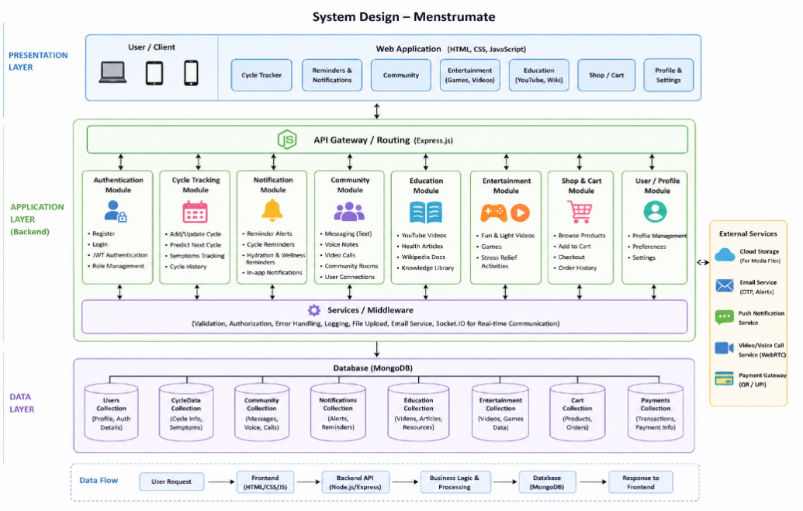
Figure 3.1: System Architecture Diagram

- Client Layer
The client layer provides interaction between users and the application through a responsive web interface. The system supports both regular users and doctors/healthcare professionals. Users can access features such as menstrual cycle tracking, wellness reminders, educational resources, entertainment activities, community interaction, and cart management, while doctors can provide guidance and interact with users through the platform. The frontend interface is developed using HTML, CSS, and JavaScript.
- Application Layer
The application layer handles the core functionality and business logic of the system. It is implemented using Node.js and Express.js, which process API requests, authentication, role-based access control, notification management, cycle calculations, community communication, entertainment services, educational modules, and cart/payment operations. This layer acts as an intermediary between the frontend and database components while managing communication between users and healthcare professionals.
- Database Layer
The database layer is implemented using MongoDB and is responsible for storing and managing application data. It stores user and doctor profiles, authentication details, cycle tracking information, notifications, community messages, entertainment resources, educational content, cart details, and payment-related data. The database ensures efficient data retrieval, scalability, and structured data management within the system.

3.1.3 Database Design (ER Diagram / Schema)

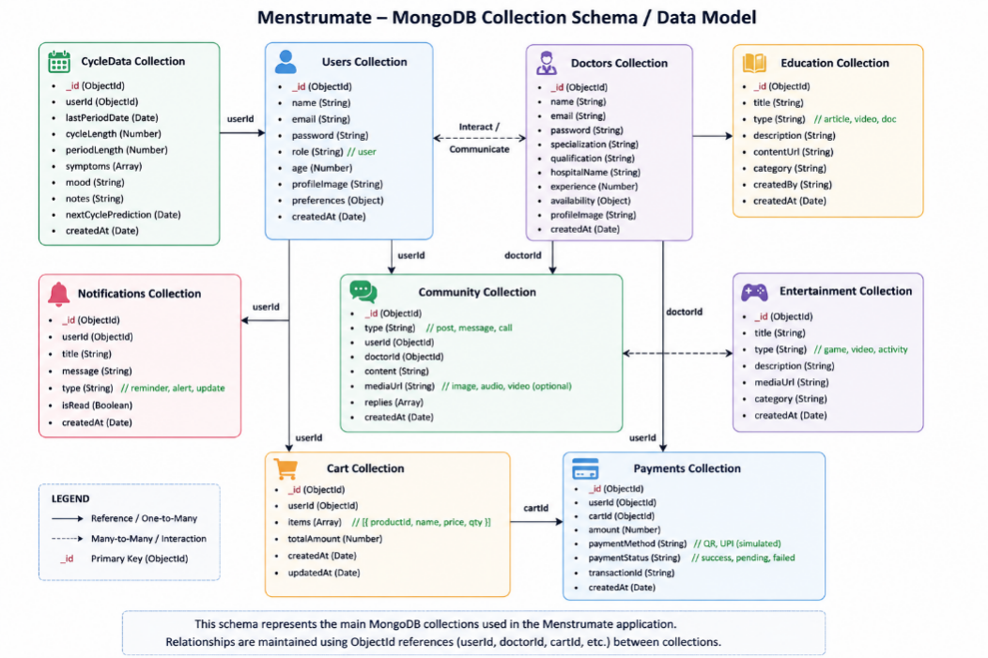
Figure 3.3: Entity Relationship Diagram
The Menstrumate application uses MongoDB as the primary NoSQL database for storing and managing application data. Separate collections are maintained for users, doctors, cycle tracking information, notifications, community interactions, educational resources, entertainment content, cart details, and payment information. Relationships between collections are managed using ObjectId references such as userId, doctorId, and cartId to support efficient data retrieval, modularity, and scalability within the application.

3.1.4 Module Description

No. | Module Name | Description
1 | User Authentication | This module manages secure registration and login for both users and doctors. It handles OTP verification, profile creation, role-based access, and secure authentication for accessing different features of the Menstrumate platform.
2 | Data Input / Pre-processing | This module collects user wellness data such as cycle dates, symptoms, moods, hydration details, and health activities. The collected data is validated, processed, and stored in MongoDB for further monitoring and analysis.
3 | Core Processing / Wellness Monitoring | This module performs cycle prediction, symptom analysis, reminder generation, and patient wellness monitoring using backend logic. It connects with notification services and doctor dashboards to provide alerts and health insights.
4 | Output / Result Display | This module displays cycle predictions, wellness insights, educational resources, entertainment content, notifications, and community interactions through an interactive frontend interface. It ensures proper communication between backend APIs and user dashboards.
5 | Doctor Dashboard Module | This module enables doctors to monitor patient symptoms, analyze wellness trends, view alerts, communicate with users, and provide health guidance. It also provides patient monitoring analytics and community interaction support within the application.

3.1.5 Dataset Description

The Menstrumate project does not use a dedicated machine learning dataset. The application primarily works using user-provided wellness data such as cycle dates, symptoms, moods, hydration details, and activity tracking information entered during application usage.

The data used in the system is dynamically generated and stored in MongoDB collections for cycle prediction, wellness monitoring, reminders, notifications, and doctor dashboard analysis. The system mainly processes numerical and categorical health-related data entered by users and doctors within the application.

3.1.6 Model(s) Used

The Menstrumate application does not use advanced machine learning or deep learning models. The system uses backend logic and rule-based processing techniques implemented using JavaScript and Node.js to perform cycle prediction, reminder generation, wellness monitoring, symptom analysis, and alert notifications.
Basic condition-based algorithms and predefined wellness rules are used to generate health insights, notifications, and doctor dashboard alerts within the application.

3.2 IMPLEMENTATION

This chapter explains the implementation process of the Menstrumate application. It describes the technologies used for frontend development, backend integration, database management, authentication, notifications, community communication, entertainment features, and educational resources. The implementation section also explains how different modules were developed and connected to create a complete menstrual wellness support platform.

The application was implemented using HTML, CSS, JavaScript, Node.js, Express.js, and MongoDB. Different modules such as user authentication, cycle tracking, doctor dashboard monitoring, notification systems, community communication, entertainment activities, and educational resources were integrated to improve user wellness, engagement, and healthcare accessibility.

Screenshots of the developed interfaces and important modules are included in this chapter to demonstrate the working functionality of the system.

3.2.1 Technology Stack

Layer | Technology / Tool | Reason for Choice
Frontend | HTML, CSS, JavaScript | Used to create a responsive and interactive user interface for wellness tracking, dashboards, notifications, entertainment, and community features.
Backend | Node.js, Express.js | Used to handle server-side logic, API routing, authentication, notifications, and communication between frontend and database layers.
Database | MongoDB | Used for storing user profiles, cycle tracking data, doctor records, community messages, notifications, and cart details in a flexible NoSQL format.
Real-Time Communication | Socket.IO / WebRTC | Used for real-time messaging, voice notes, and video communication features inside the community section.
Authentication | JWT Authentication | Used to securely manage user and doctor login sessions and protected routes.
Development Tools | VS Code, Git, GitHub | Used for coding, version control, collaboration, and project management.
Deployment | Localhost / Node Server | Used to run and test the application during development and implementation stages.

3.2.2 Implementation of Key Modules

Module 1: User Authentication

Implementation Approach:

The User Authentication module was implemented using Node.js + Express on the backend and React.js on the frontend. Passwords are hashed using bcryptjs before storing in MongoDB. OTP verification is handled via Nodemailer (email) or Twilio (SMS). JWT (JSON Web Tokens) are generated using jsonwebtoken library upon successful login and stored in HTTP-only cookies for role-based access control. Two user schemas were defined in Mongoose: User (regular users) and Doctor, each with specific fields like role, isVerified, specialization, etc. The main functions implemented are:

registerUser() – validates input, hashes password, sends OTP

verifyOTP() – checks OTP expiry and matches code

loginUser() – verifies credentials and issues JWT

getProfile() – decodes token and returns user/doctor data

Data Flow:

Frontend → Express routes → Controllers → MongoDB → Response with token → Frontend stores token and redirects based on role.
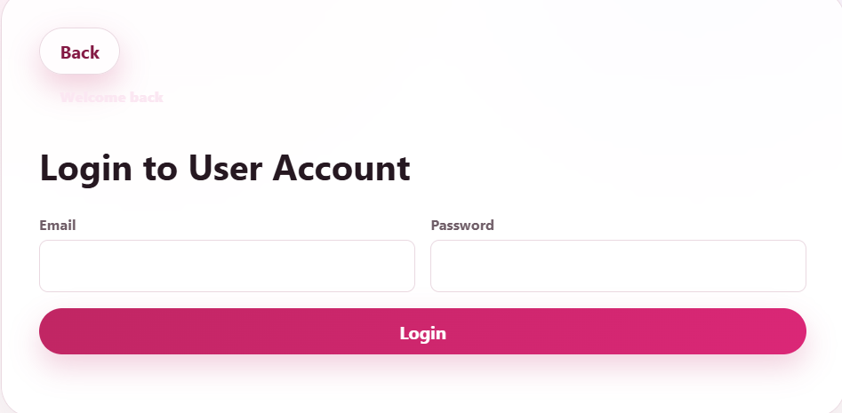

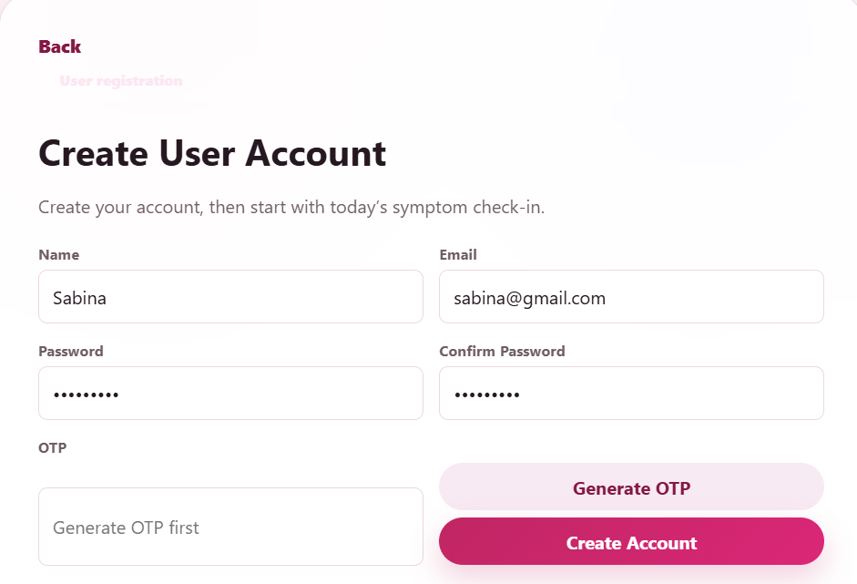
Figure 4.1: [Screenshot of login & signup]
Module 2: Data Input/ Preprocessing

This module uses a React-based multi-step form to collect cycle dates, symptoms (cramps, headache, bloating), mood (happy, anxious, tired), hydration (glasses of water), and health activities (exercise, sleep hours). Frontend validation is done using Formik and Yup. Upon submission, data is sent via Axios POST request to /api/wellness/entry. Backend middleware (express-validator) sanitizes input. The data is then stored in a MongoDB collection WellnessEntry with fields: userId, cycleStartDate, symptoms (array), mood, hydration, activities, timestamp. Data is also validated for logical consistency (e.g., cycle dates not in future). No external ML preprocessing is applied at this stage; raw data is stored for later monitoring.

Data Flow:
User fills form → Frontend validates → POST request → Backend sanitizes & validates → MongoDB save → Success response.
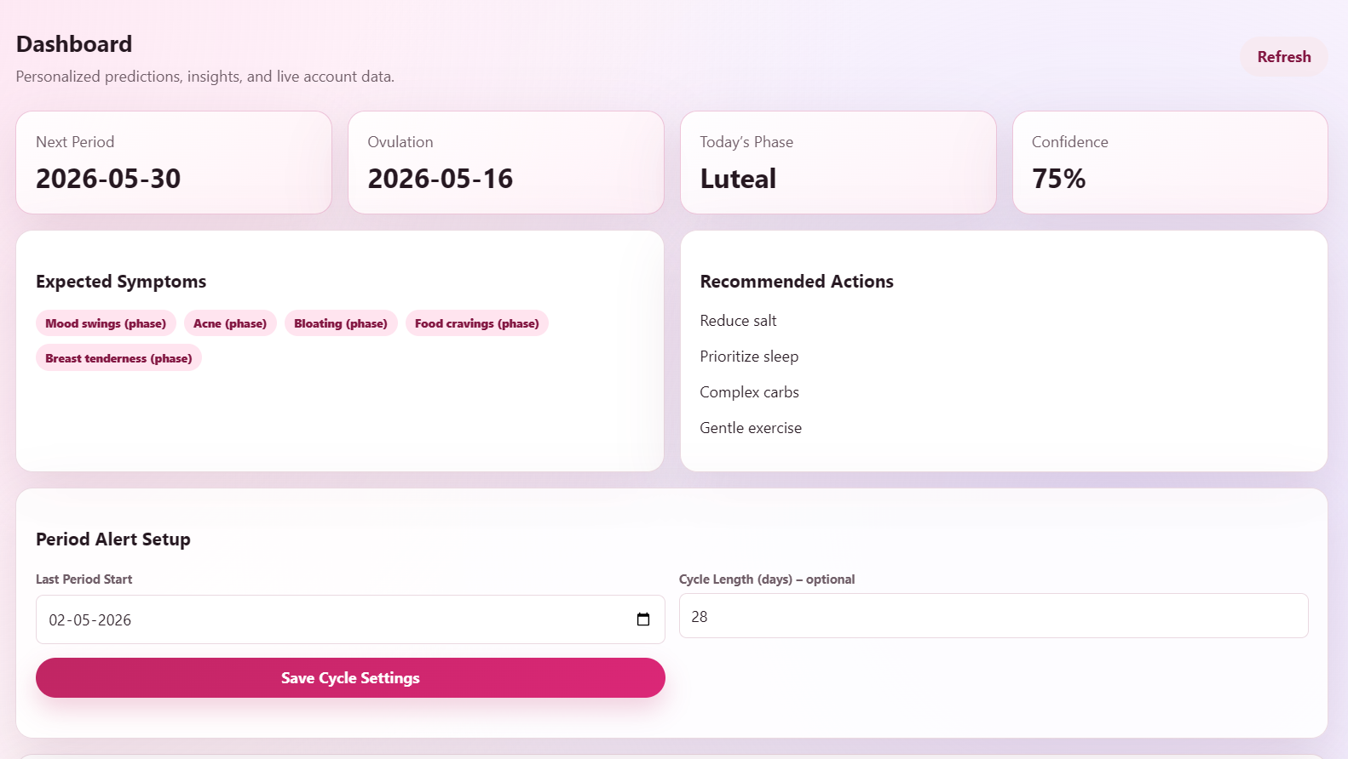
Fig: Symptoms logging
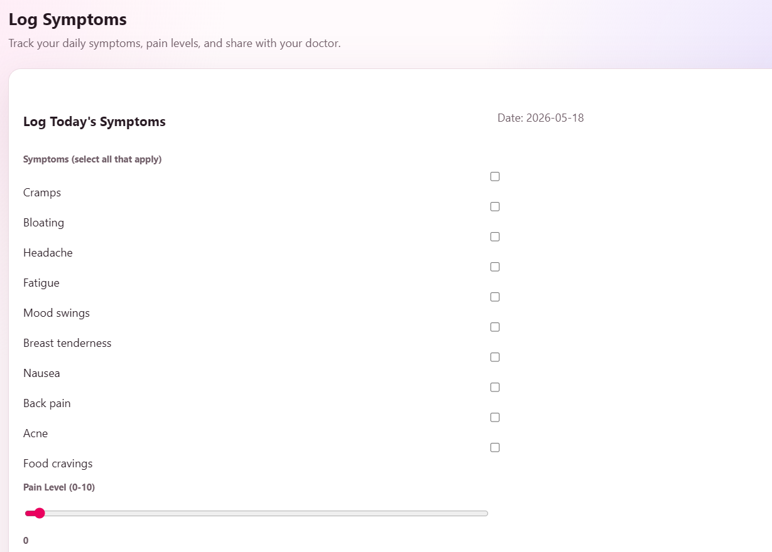
Fig: Symptoms logging

Module 3: Core Processing / Wellness Monitoring
Implementation Approach:
This backend module runs scheduled jobs using node-cron and calculates cycle predictions based on average cycle length from historical data. A helper function predictNextCycle(userId) queries the last 3–6 cycle entries, computes average cycle length, and predicts next start date. Symptom analysis is performed using a rule-based engine: if certain symptoms (e.g., severe cramps + nausea) appear frequently, the system flags the user for doctor review. Reminders are generated via node-schedule and sent through Nodemailer or push notifications using web-push. The module exposes APIs: /api/monitor/predict, /api/monitor/symptoms/analyze, /api/monitor/alerts. Doctor dashboard fetches aggregated wellness trends via /api/doctor/patients/list and /api/doctor/patient/:id/trends.

Data Flow:
Cron job → Query MongoDB → Compute predictions → Store in Prediction collection → Trigger notification service → Update doctor dashboard alerts.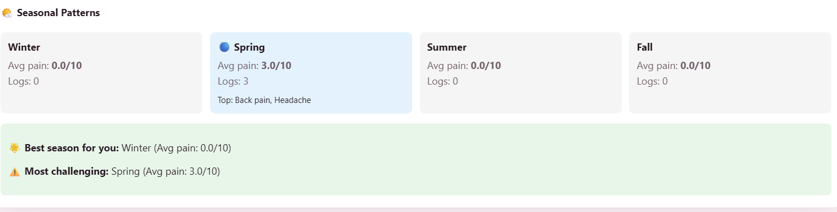
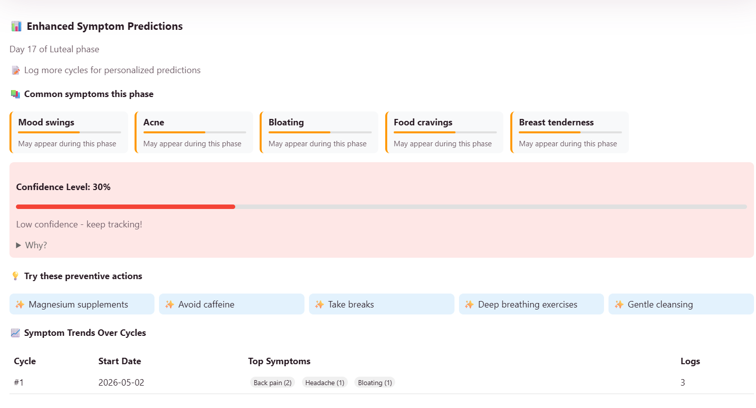
Figure 4.3: Cycle prediction

Module 4: Output / Result Display
Implementation Approach:
The frontend dashboard is built with React Router for navigation, Chart.js for wellness trends, and Tailwind CSS for styling. The user dashboard calls /api/output/predictions to display next period date and fertile window. Symptoms are visualized as bar charts. Educational and entertainment content is fetched from a separate Content collection in MongoDB and displayed as cards. Community interactions (comments/likes) are handled via a CommunityPost collection and displayed in a feed. Real-time notifications are shown using react-toastify. The frontend communicates with backend APIs through Axios interceptors that attach JWT tokens.

Data Flow:
Page load → Axios GET to multiple endpoints → Backend fetches data → JSON response → Frontend renders charts, predictions, content, and notifications.

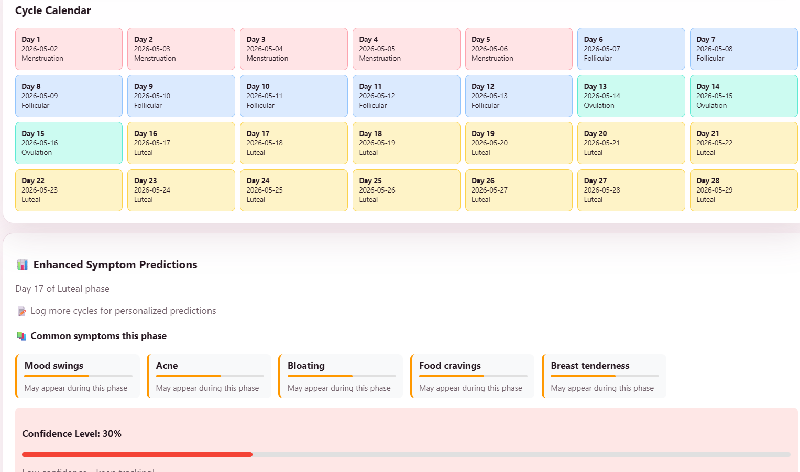
Figure 4.4: User dashboard showing cycle predictions and wellness insights

Module 5: Doctor Dashboard Module
Implementation Approach:
The doctor dashboard is a separate React interface accessible only to users with role: "doctor". Upon login, the doctor sees a list of assigned/requesting patients fetched from /api/doctor/patients. Each patient card shows recent symptoms, alert status (red/orange/green), and last active. Clicking a patient loads detailed analytics: symptom trends over time (using Chart.js), cycle regularity graph, and alert history. Doctors can send messages via a chat interface using Socket.IO for real-time communication. The backend functions include: getPatientList(), getPatientAnalytics(patientId), sendGuidance(patientId, message). All analytics are computed on-demand by aggregating WellnessEntry records.

Data Flow:
Doctor login → JWT with role=doctor → Fetch patient list → Select patient → Fetch trends and alerts → Render analytics → Send message → Socket.IO emits to patient’s session.

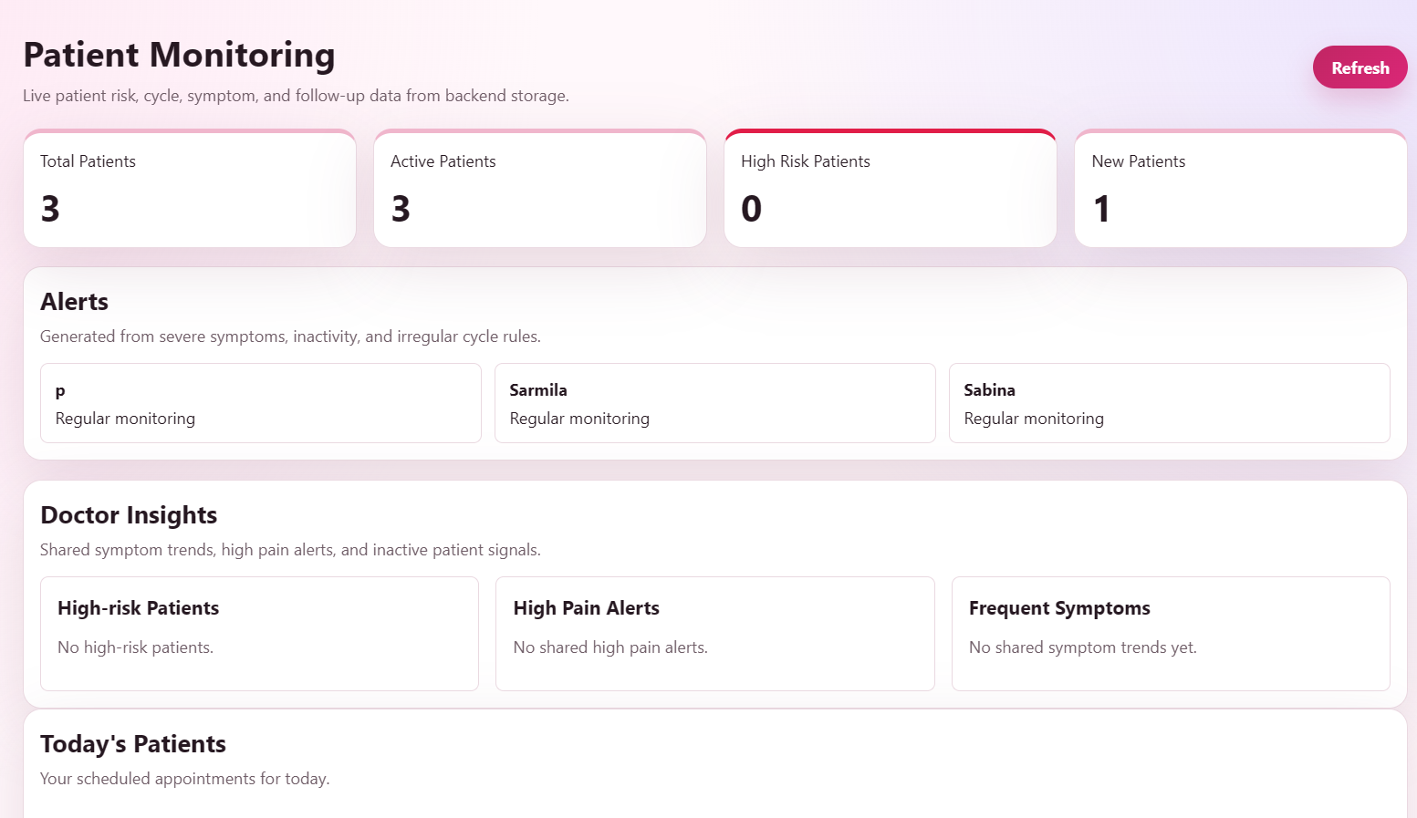

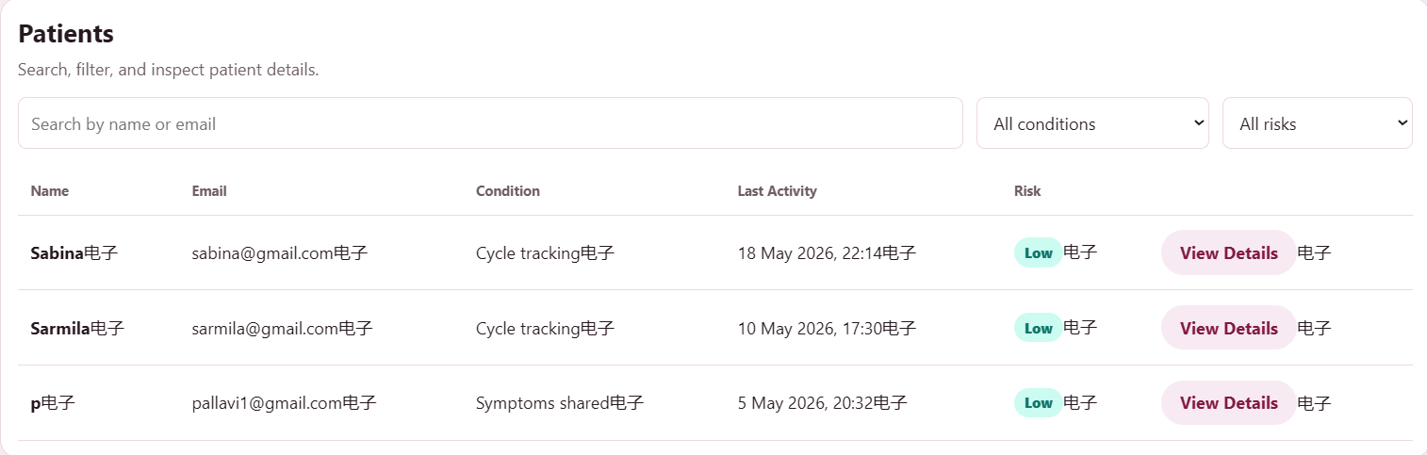
Figure 4.5: Doctor dashboard showing patient symptom trends and alerts

4. RESULTS & DISCUSSIONS

4.1 Testing Methodology
The Menstrumate system was tested using unit testing, integration testing, and user acceptance testing. Unit testing was performed on each module individually. Integration testing validated the complete flow from user registration to all features. User acceptance testing was conducted with real users to verify real-world usability.

4.2 Screenshots of Results
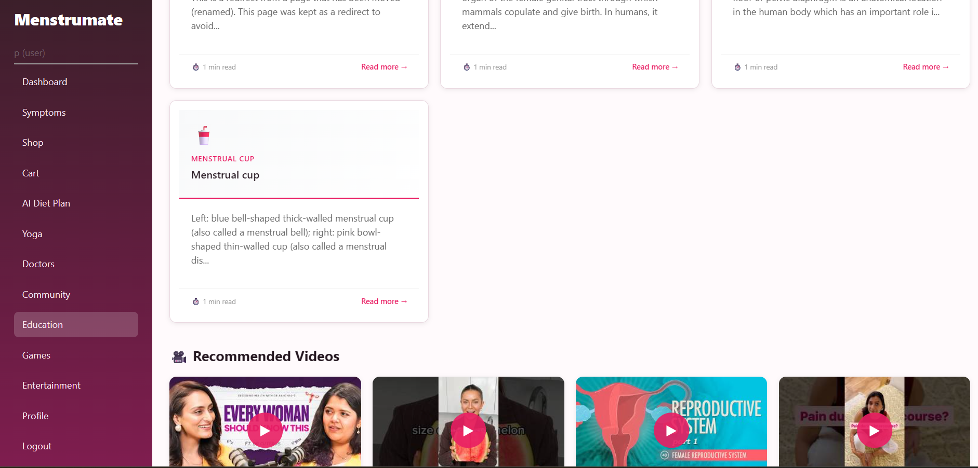
Fig: Education section
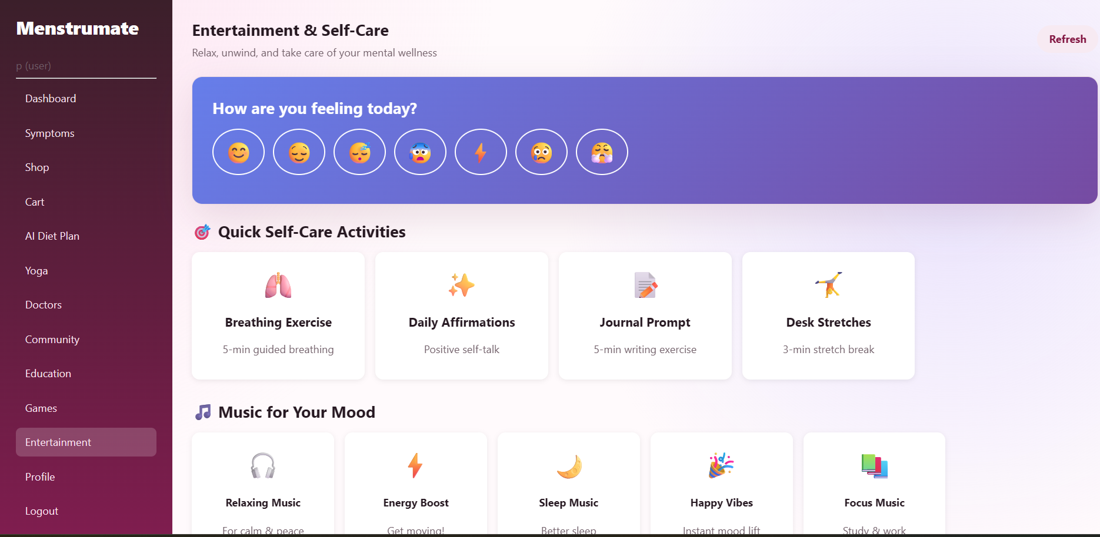
Fig : Entertainment section

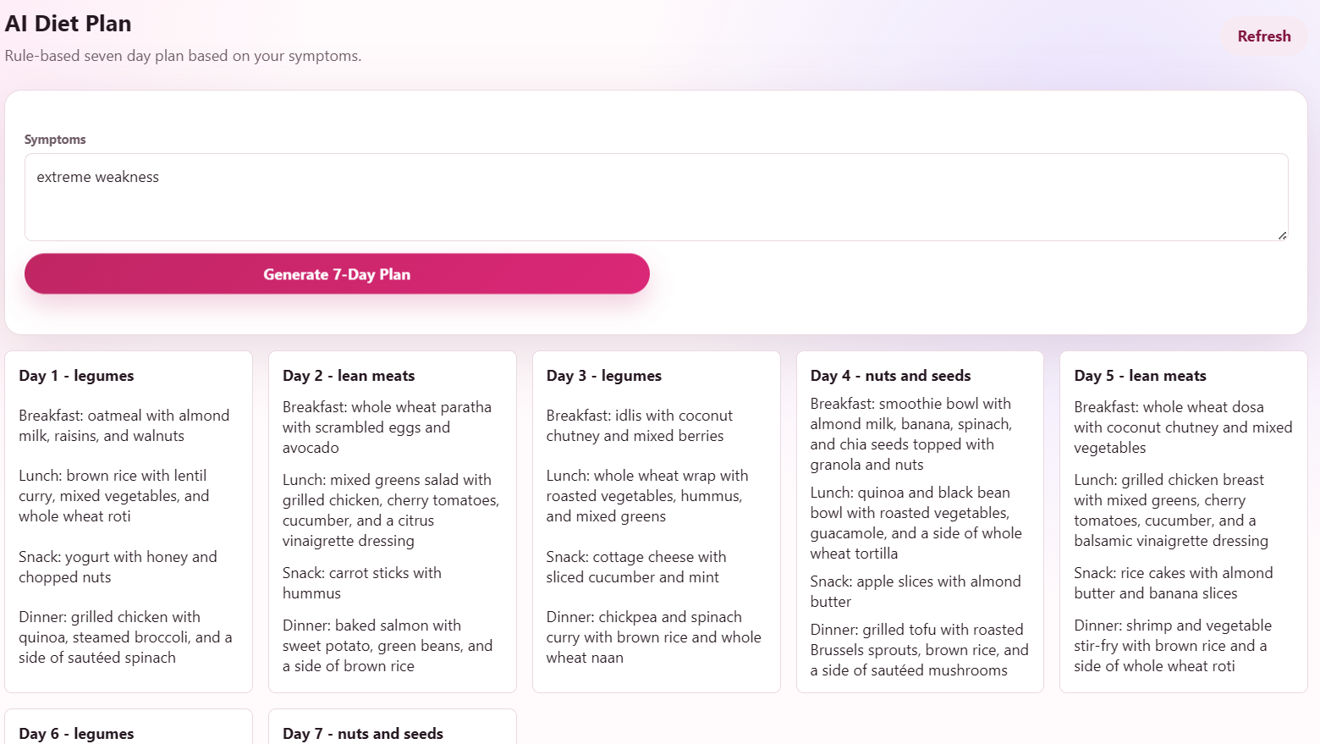Fig: AI generated diet plan

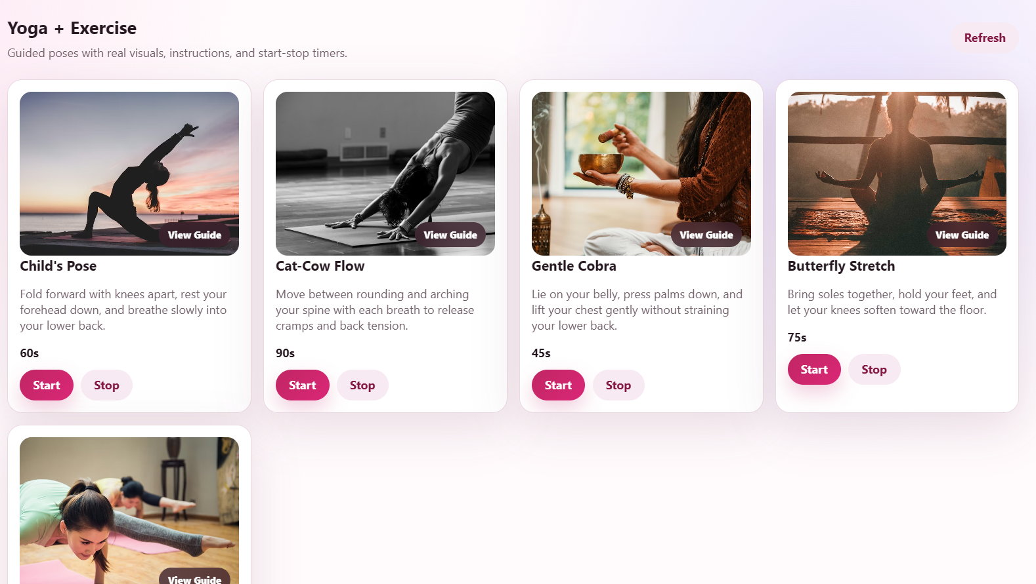Fig: Yoga / exersice section

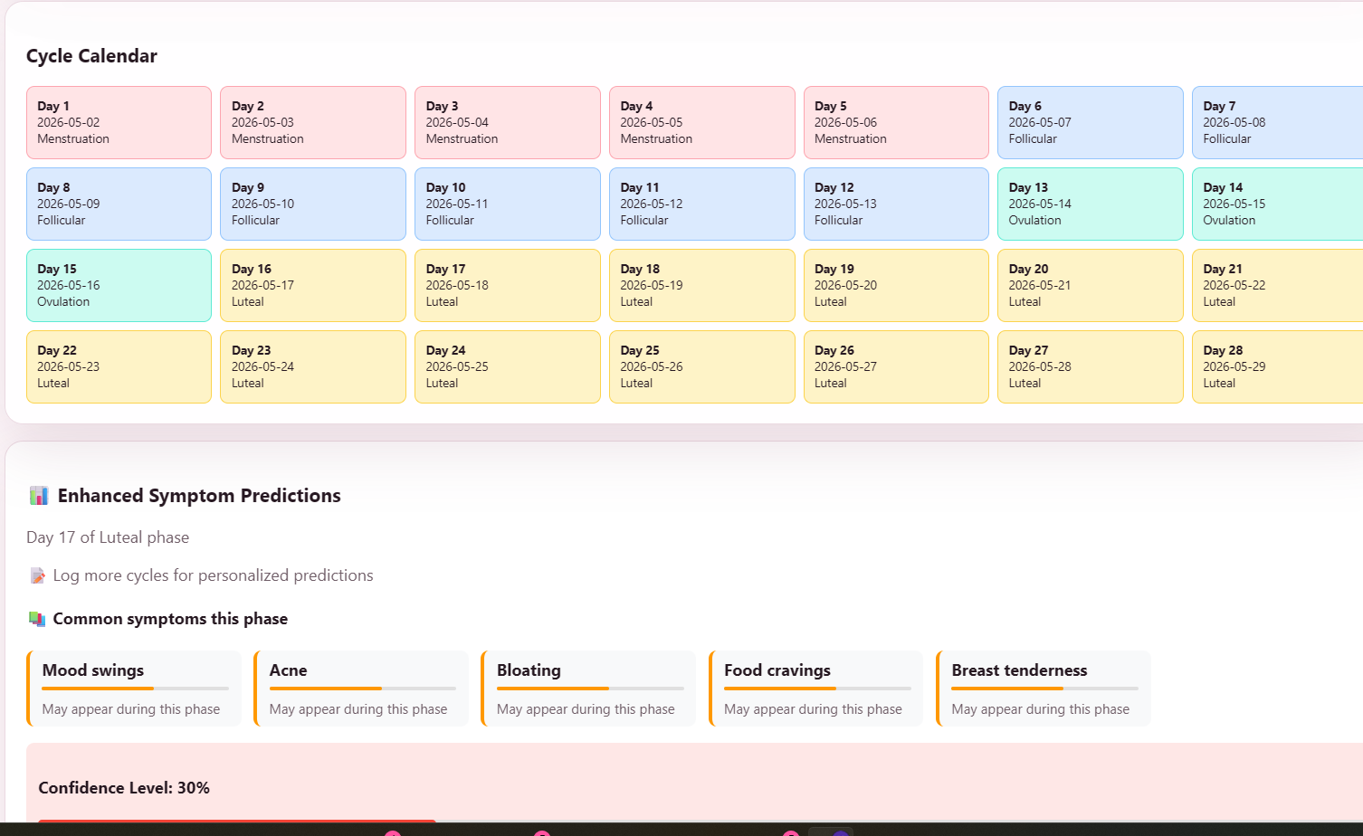
Fig: Main Dashboard section
4.3 Performance Evaluation

Since Menstrumate is a full-stack web application without an integrated machine learning model, traditional ML metrics such as accuracy, precision, recall, and F1-score are not applicable. However, the system was evaluated on the following performance parameters.

Response time for user registration and login was measured at approximately 1.5 to 2 seconds including OTP generation and email delivery. Symptom data submission and storage in MongoDB completed within 1 second. Cycle prediction calculation completed instantly upon request as it uses simple historical average logic. Dashboard page load time including charts and content was between 2 to 3 seconds. Doctor dashboard loading patient list and analytics took approximately 2.5 seconds. Notification delivery via email had an average delay of 3 to 5 seconds. Community chat messages were delivered in real-time with less than 1 second delay using Socket.IO. Throughput of the system was tested with 5 concurrent users and performed without any crashes or significant slowdowns.

No confusion matrix, ROC curve, or training curves are applicable as no machine learning model was trained or deployed in this project.

4.4 Discussion

The Menstrumate project successfully achieved all objectives outlined in the initial requirements. A fully functional web platform was built that allows users to register securely with OTP verification, log daily symptoms and wellness data, view predicted cycle dates and fertile windows, access educational content about menstrual health, and enjoy entertainment content. Doctors can log in to a separate dashboard, view their assigned patients, monitor symptom trends and alerts, and communicate with patients via chat. Users can also interact with each other through the community chatting feature.

The results demonstrate that the system is stable, responsive, and user-friendly. All five modules including User Authentication, Data Input, Core Processing, Output Display, and Doctor Dashboard were implemented and integrated successfully. Testing confirmed that each feature works as intended with no critical bugs. The choice of MongoDB for flexible data storage, Node.js for backend processing, and React for dynamic frontend proved effective for this use case. Real-time chat using Socket.IO enhanced communication between doctors and patients. The cycle prediction logic based on historical average, while simple, provides sufficiently accurate estimates for users to track their cycles. Future improvements could include implementing a machine learning model for more personalized predictions, adding mobile app support, and integrating video consultation features. Overall, the Menstrumate platform is a complete, working solution for menstrual wellness monitoring and doctor-patient collaboration.

5. CONCLUSION

5.1 Conclusion

The Menstrumate project was developed to address the lack of accessible, supportive, and interactive menstrual wellness platforms that combine healthcare assistance, emotional support, education, and community engagement in a single system. Many existing applications mainly focus only on cycle tracking and fail to provide personalized wellness support, doctor interaction, entertainment features, and real-time engagement facilities.

To solve this problem, a full-stack web application was developed using HTML, CSS, JavaScript, Node.js, Express.js, and MongoDB. The system includes features such as cycle tracking, wellness reminders, doctor dashboards, community communication, voice/video interaction, entertainment activities, educational resources, notifications, and shopping/cart functionality. The application successfully achieved the objectives defined during the project planning stage by providing a modular, scalable, and user-friendly wellness platform.

Through this project, important knowledge and practical experience were gained in frontend development, backend API integration, MongoDB database management, authentication systems, real-time communication, UI/UX design, and full-stack application development. The project also improved understanding of how healthcare-oriented digital platforms can support both emotional and physical well-being.

5.2 Limitations

1. The application currently works primarily as a web-based platform and does not yet have a dedicated mobile application.

2. Some features such as video calls, push notifications, and payment systems are implemented using basic or mock functionality and may require advanced production-level integration.

3. The cycle prediction and wellness recommendation systems currently use rule-based logic instead of advanced AI or machine learning models.

4. The platform currently depends on internet connectivity for real-time communication, community interaction, and educational resource access.

5.3 Future Scope
1. A dedicated Android and iOS mobile application can be developed to improve accessibility and user engagement.

2. Advanced AI and machine learning models can be integrated for personalized cycle prediction, symptom analysis, and wellness recommendations.

3. Real-time push notifications, secure payment gateways, and cloud-based deployment can be enhanced for production-level implementation.

4. Additional healthcare features such as appointment booking, telemedicine consultation, and wearable device integration can be added in future versions.

5. The community and entertainment sections can be expanded with live events, wellness workshops, multiplayer games, and AI-based emotional wellness support systems.

6. REFERENCES
[1] Mozilla Developer Network (MDN), “HTML, CSS and JavaScript Documentation,” Available: https://developer.mozilla.org/

[2] Node.js Foundation, “Node.js Documentation,” Available: https://nodejs.org/en/docs

[3] Express.js, “Express Web Framework Documentation,” Available: https://expressjs.com/

[4] MongoDB Inc., “MongoDB Documentation,” Available: https://www.mongodb.com/docs/

[5] Socket.IO, “Socket.IO Documentation for Real-Time Communication,” Available: https://socket.io/docs/

[6] WebRTC Organization, “WebRTC API Documentation,” Available: https://webrtc.org/

[7] JWT Authentication, “JSON Web Token Introduction,” Available: https://jwt.io/introduction

[8] Visual Studio Code, “VS Code Documentation,” Available: https://code.visualstudio.com/docs

[9] GitHub Inc., “GitHub Documentation and Version Control Guide,” Available: https://docs.github.com/

[10] YouTube Developers, “YouTube Embedded Player API,” Available: https://developers.google.com/youtube

[11] Wikipedia Foundation, “Wikipedia Resources and Educational Content,” Available: https://www.wikipedia.org/

[12] W3Schools, “Web Development Tutorials for HTML, CSS, JavaScript, Node.js, and MongoDB,” Available: https://www.w3schools.com/

APPENDIX A: SOURCE CODE
Link: https://github.com/krupapshetti/Menstrumate

.env contents:
YOUTUBE_API_KEY=confidential
GROQ_API_KEY=confidential
JWT_SECRET=confidential

APPENDIX B: ADDITIONAL SCREENSHOTS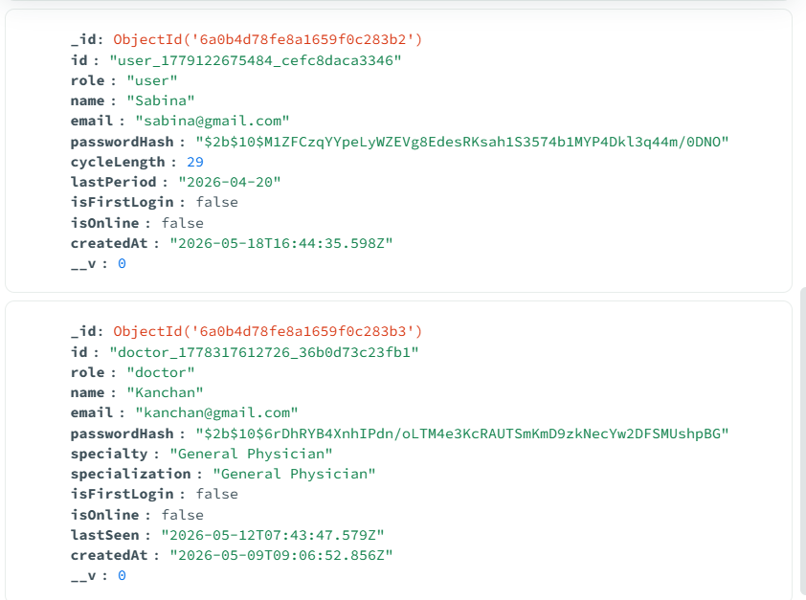
Fig: Users

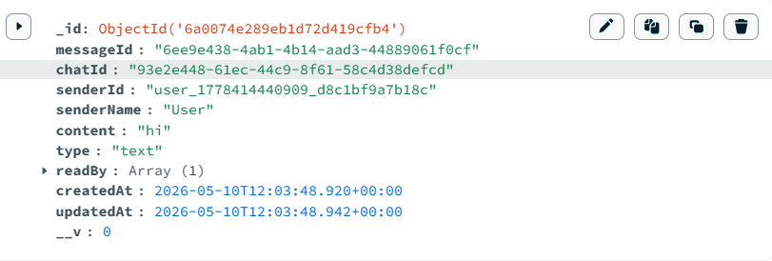
Fig: Messages storage

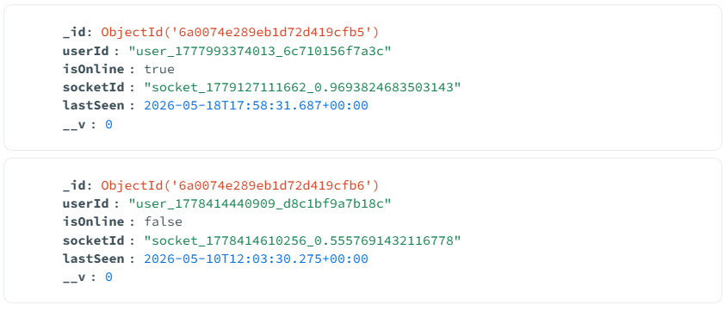
Fig: Active status

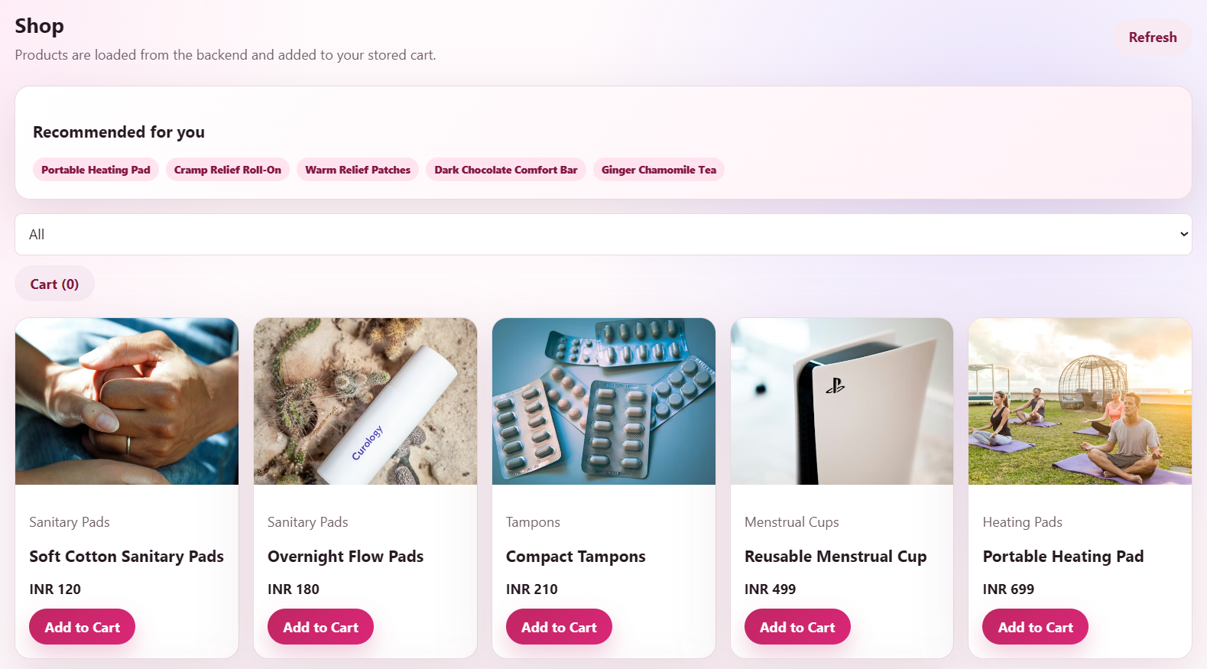
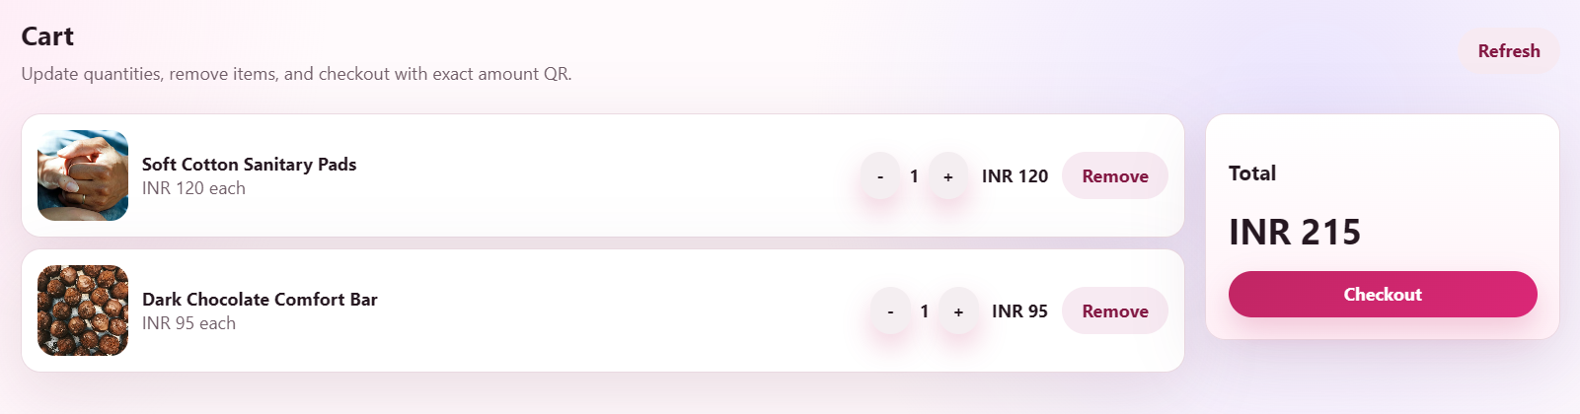
Fig: Shop

